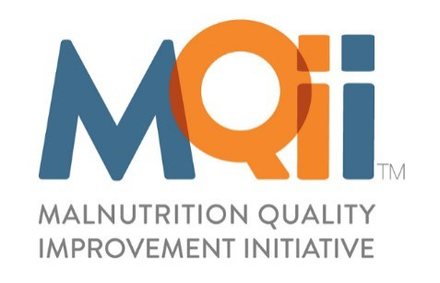

MQii Learning Collaborative Participation Agreement

2022 First Amendment

This First Amendment, effective January 5, 2021 (“Amendment Effective Date”), and shall serve as an amendment to the 2021 MQii Learning Collaborative Participation Agreement (“MQii Agreement”) for partnership with Avalere Health, LLC (“Avalere”) a Maryland limited liability company, with its corporate office located at 1201 New York Avenue NW, Suite 1000, Washington, DC 20005 and _______ (“Participant”) located at ________, each referred to individually as a “Party” or collectively as “Parties.”
WHEREAS the Parties entered into the MQii Agreement on ________.
WHEREAS the Parties hereby agree to extend the term of the MQii Agreement in accordance with the terms of the MQii Agreement as well as amend certain terms of the MQii Agreement as provided herein.
In consideration of the mutual covenants contained herein, the Parties mutually covenant and agree as follows:
- The MQii Agreement, which is attached as Exhibit A, hereto as a part of this Amendment, is scheduled to end on December 31, 2021.
- The Parties agree to extend the MQii Agreement through December 31, 2022, unless terminated earlier by either Party upon thirty (30) days’ prior written notice of termination.
- The Parties agree to amend the terms in Section III of the MQii Agreement as follows:
  - Section III, Subsection A, Subparagraph 3e. Avalere Responsibilities shall be amended to reflect new dates for performance benchmark reports in Q3 2022 and Q1 2023 as follows: the first report will be released by Q3 2022 and the second report will be released by Q1 2023. This same timeline will also apply to each subsequent year of participation.
  - Section III, Subsection B, Subparagraphs 3b and 3c. Participant Responsibilities shall be amended as follows:
i. Item 3b is hereby amended to state: Participant agrees to transmit performance data on a monthly recurring basis to receive performance feedback throughout calendar year 2022 and each subsequent calendar year.
ii. Item 3c is hereby amended to reflect the following reporting periods: Reporting Period #1 requested by May 1, 2022: Q1 2022 – Jan, Feb, Mar 2022; Reporting Period #2 requested by Aug 1, 2022: Q2 2022 – Apr, May, June 2022; Reporting Period #3 requested by Nov 1, 2022: Q3 2022 – July, Aug, Sept 2022; Reporting Period #4 requested by Feb 1, 2023: Q4 2022 – Oct, Nov, Dec 2022. The same pattern will apply in each subsequent calendar year.
- This Amendment, including the attached MQii Agreement, is the entire agreement between the Parties. No other terms of the MQii Agreement not amended herein shall be altered.

READ, AGREED, and ACCEPTED as of the day and year first set forth above.
HOSPITAL / HEALTH SYSTEM NAME

AVALERE HEALTH, LLC | _______________
By: | Signature:
Name: | Name:
Title: | Title:
Date: | Date:

